Internationally
Recognized

UET Graduates are
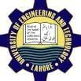
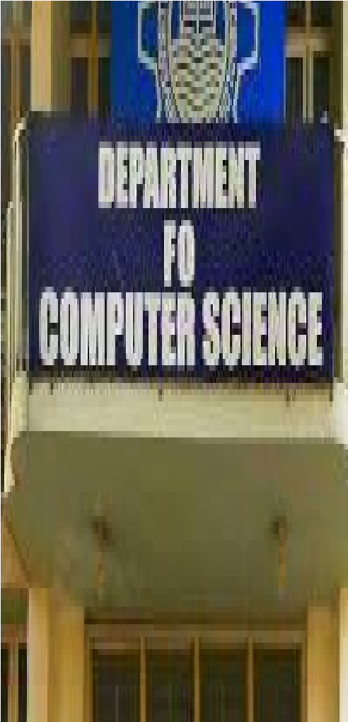
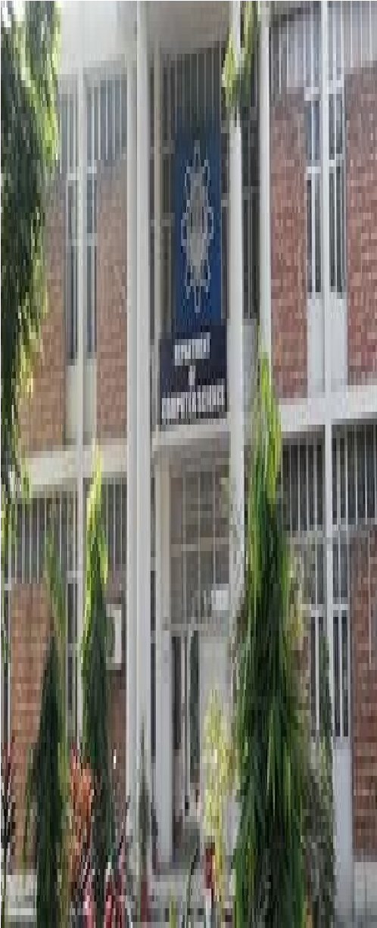
Eligible To work Department of
Globally As it is COMPUTER
Associated To SCIENCE and Washington ENGINEERING, UET Accord. Programs Lahore.
offered in the
Computer Science

Department Are Recognized By Washington Accord.

Visit Us Online

lms.uet.edu.pk

cse.uet.edu.pk

uet.acm@gmail.com

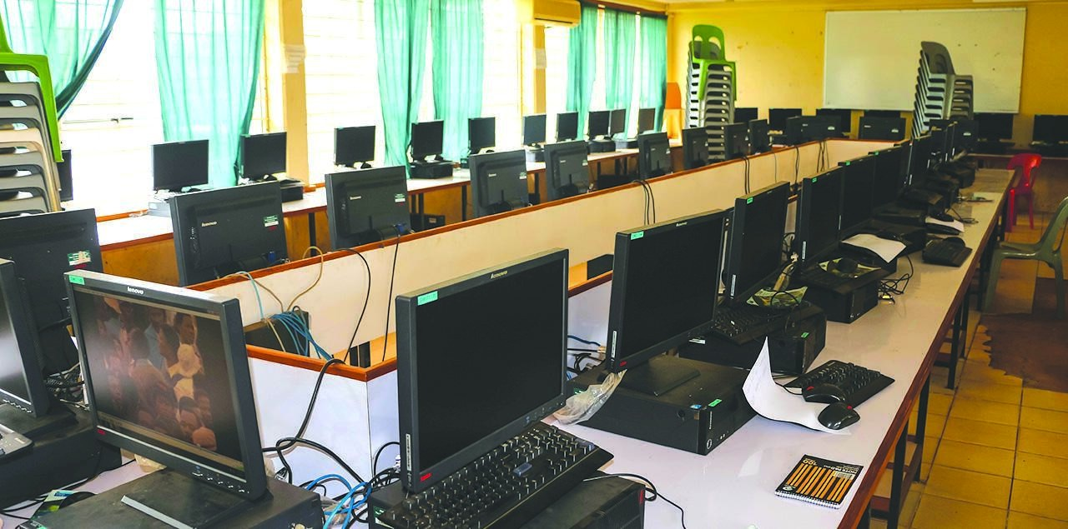
Dean: Prof. Dr. Suhail

“The Science of Aftab qurashi
Today is the
Technology of Chairman: Prof. Dr.
Tomorrow”. Muhammad Shahbaz

EDWARD TELLER

Contact Us
Technical Society
UET Admissions
UET ACM is one of the
042-9902912
most celebrated scientific
society which is actively
Registrar:
participated in different
Courses Offered 042-99029277
events in collaboration

with ICOSST (KICS),
- BSc Computer
Sciences Deputy Registrar:
- BSc Computer ● IEEE UET Society 042-99029417 engineering ● COMPUTER
- MSc Computer CLUB
Science ● IET SOCIETY
- MSc Computer

Engineering

Careers COMPUTER FACILITIES

Software The computer cell is Development providing complete
Network & Computer facilities with the System Administor’s advance internet
Computer Network
& service to whole
Architects universities.

